DAY 11 — MATPLOTLIB
Date :-24/09/2026
1. What is Matplotlib?
Description
Matplotlib is a Python library used to create data visualizations such as:
- Line chart
- Bar chart
- Histogram
- Scatter plot
- Pie chart
- Box plot
- Area chart
Visualization helps us understand data easily and communicate information clearly.
Installation
pip install matplotlib
Import
import matplotlib.pyplot as plt
Create One Dataset
We will use one Sales Dataset for all Day 50charts.

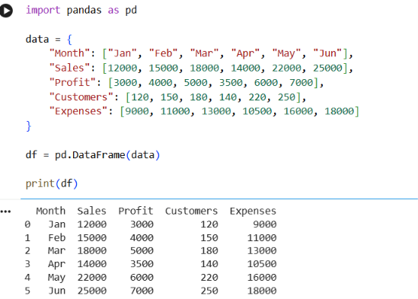
1. Line Chart
Description
A line chart is used to show trends or changes over time.
Example
We want to see how sales changed from January to June.
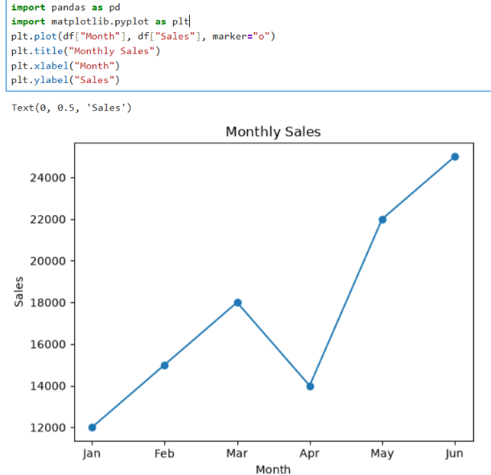
2. Bar Chart
Description
A bar chart compares values between different categories.
plt.bar(df["Month"], df["Sales"])
plt.title("Monthly Sales Comparison")
plt.xlabel("Month")
plt.ylabel("Sales")
plt.show()
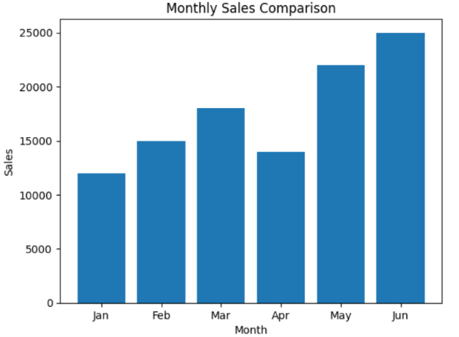
Interpretation
June has the highest sales, while January has the lowest sales.

3. Histogram
Description
A histogram shows the distribution of numerical data.
plt.hist(df["Sales"], bins=5)
plt.title("Sales Distribution")
plt.xlabel("Sales")
plt.ylabel("Frequency")
plt.show()

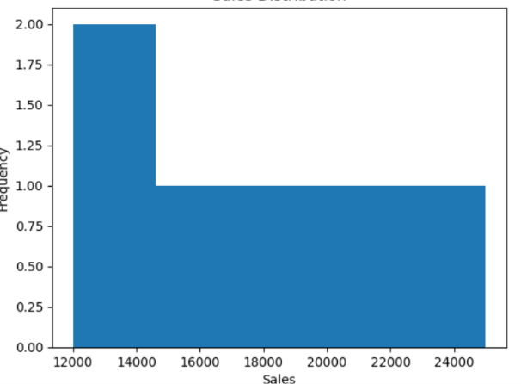
Interpretation
The histogram shows how the sales values are distributed across different ranges.
4. Scatter Plot
Description
A scatter plot shows the relationship between two numerical variables.
Here we compare Sales and Profit.
plt.scatter(df["Sales"], df["Profit"])
plt.title("Sales vs Profit")
plt.xlabel("Sales")
plt.ylabel("Profit")

plt.show()
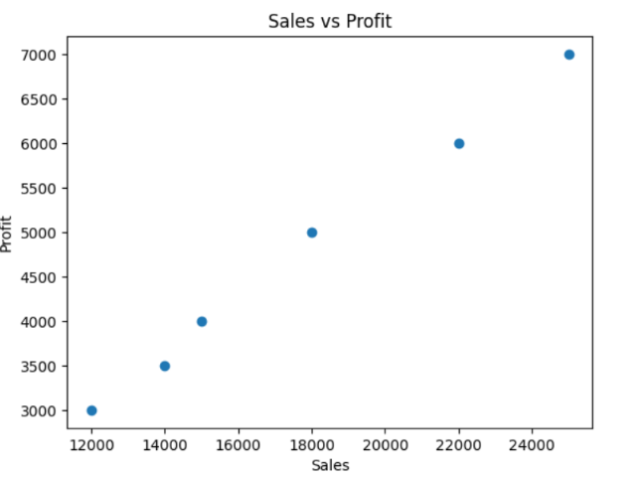
Interpretation
As sales increase, profit also generally increases. This indicates a positive relationship between sales and profit in this example dataset.
5. Pie Chart
Description
A pie chart shows the proportion of different categories as parts of a whole.
plt.pie(df["Sales"], labels=df["Month"], autopct="%1.1f%%")
plt.title("Sales Percentage by Month")
plt.show()
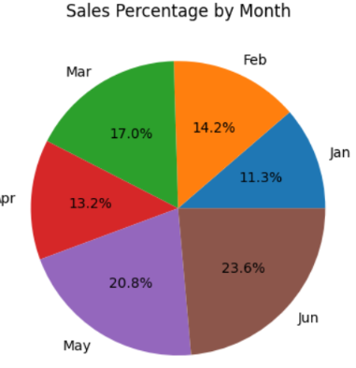
Interpretation
The pie chart shows each month's contribution to total sales. June contributes the largest share.
6. Box Plot
Description
A box plot is used to understand:
- Median
- Quartiles
- Spread
- Possible outliers
plt.boxplot(df["Sales"])
plt.title("Sales Box Plot")
plt.ylabel("Sales")
plt.show()
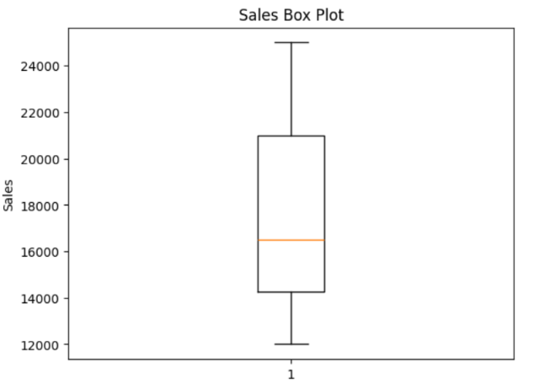
Interpretation
The box plot summarizes the distribution of sales and can help identify unusually high or low values.
8. Area Chart
Description
An area chart is similar to a line chart but fills the area below the line.
plt.fill_between(df["Month"], df["Sales"], alpha=0.5)
plt.title("Monthly Sales Area Chart")
plt.xlabel("Month")
plt.ylabel("Sales")
plt.show()
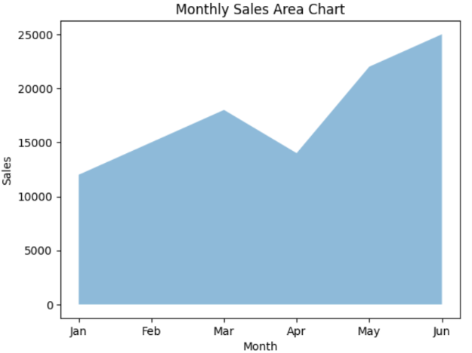
Interpretation
The filled area makes it easy to see the overall sales volume and trend over the months.

9. Multiple Line Chart
The task requires at least 10 charts, so we need additional visualizations.
We can compare Sales and Profit.
plt.plot(df["Month"], df["Sales"], marker="o", label="Sales")
plt.plot(df["Month"], df["Profit"], marker="o", label="Profit")
plt.title("Sales and Profit Trend")
plt.xlabel("Month")
plt.ylabel("Amount")
plt.legend()
plt.show()
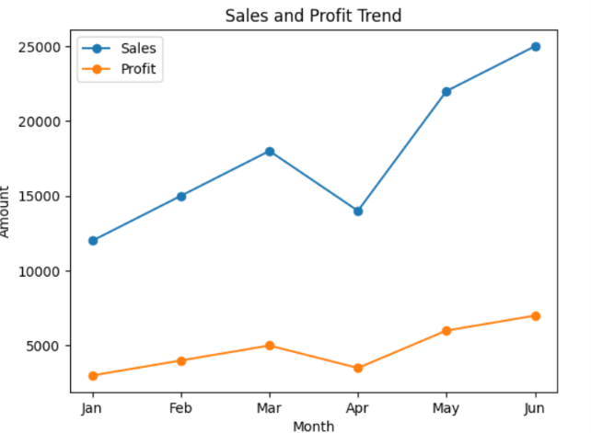
Interpretation
Sales are considerably higher than profit throughout the period, but both generally increase over time.

10. Customer Bar Chart
plt.bar(df["Month"], df["Customers"])
plt.title("Monthly Customers")
plt.xlabel("Month")
plt.ylabel("Number of Customers")

plt.show()
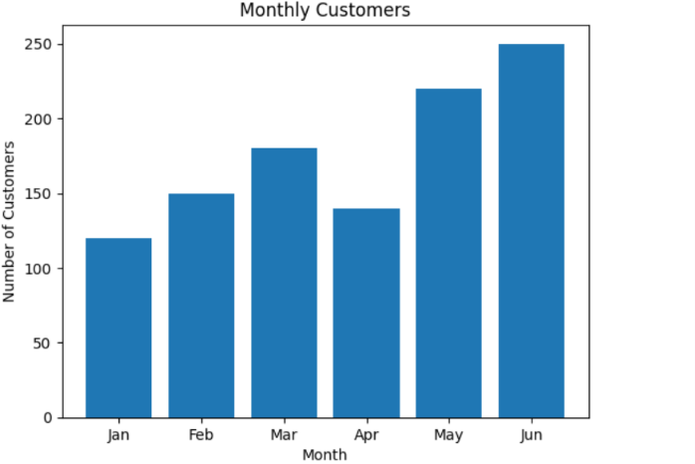

Interpretation
The number of customers generally increases from January to June, with June having the highest number of customers.

DAY 12 — SEABORN
Date:-24/09/2026
The uploaded task asks you to learn Countplot, Boxplot, Violin plot, Heatmap, Pairplot and Distribution plots.
1. What is Seaborn?
Description
Seaborn is a Python data visualization library built on top of Matplotlib.
It provides attractive and easy-to-use statistical visualizations.
Installation
pip install seaborn
Import
import seaborn as sns
import matplotlib.pyplot as plt
Create Dataset
For Seaborn categorical analysis, we will create a small employee dataset.
import pandas as pd

data = {
"Department": [
"IT", "IT", "HR", "HR", "Sales",
"Sales", "IT", "Finance", "Finance", "Sales"
],
"Gender": [
"Male", "Female", "Female", "Male", "Male",
"Female", "Male", "Female", "Male", "Female"
],
"Age": [23, 25, 30, 35, 28, 32, 26, 40, 38, 29],
"Salary": [
30000, 35000, 40000, 42000, 38000,
45000, 32000, 50000, 55000, 41000 ],
"Experience": [1, 2, 5, 7, 4, 6, 2, 10, 12, 5]
}df = pd.DataFrame(data)
print(df)
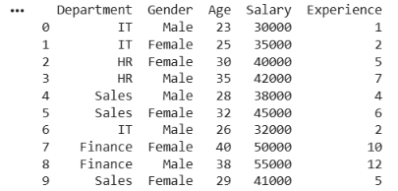
2. Countplot
Description
A countplot displays the number of observations in each category.
Example
Count employees in each department.
import seaborn as sns
import matplotlib.pyplot as plt
sns.countplot(x="Department", data=df)
plt.title("Employees by Department")
plt.xlabel("Department")
plt.ylabel("Number of Employees")
plt.show()
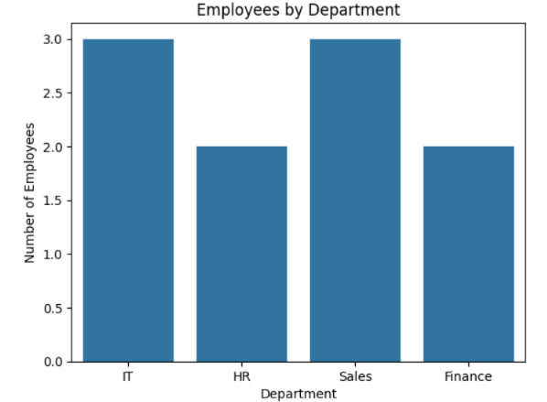

Interpretation
The chart shows how many employees belong to each department.
3. Boxplot
Description
A boxplot shows the distribution of numerical data and helps identify potential outliers.
sns.boxplot(x="Department", y="Salary", data=df)
plt.title("Salary Distribution by Department")
plt.xlabel("Department")
plt.ylabel("Salary")
plt.show()
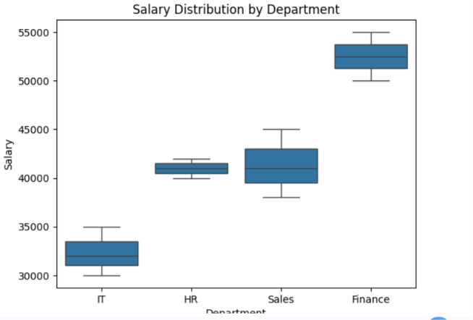
Interpretation
The boxplot allows us to compare salary distributions across departments and identify unusual salary values.
4. Violin Plot
Description
A violin plot combines features of a boxplot with a density distribution.
sns.violinplot(x="Department", y="Salary", data=df)
plt.title("Salary Distribution by Department")
plt.xlabel("Department")
plt.ylabel("Salary")
plt.show()
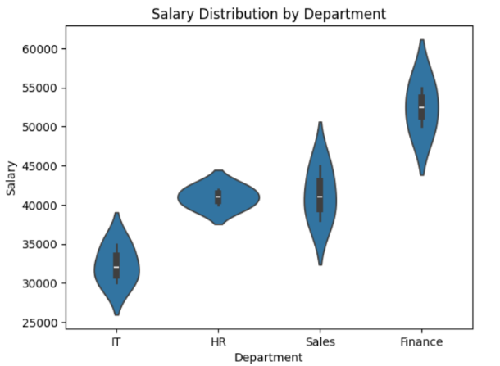
Interpretation
The width of the violin indicates where salary values are more concentrated.
5. Heatmap
Description
A heatmap represents numerical relationships using different shades.
First calculate correlation:
correlation = df[["Age", "Salary", "Experience"]].corr()
print(correlation)
Age Salary Experience
Age 1.000000 0.930522 0.965368
Salary 0.930522 1.000000 0.980017
Experience 0.965368 0.980017 1.000000
Then create heatmap:
sns.heatmap(
correlation,
annot=True
)
plt.title("Correlation Heatmap")
plt.show()
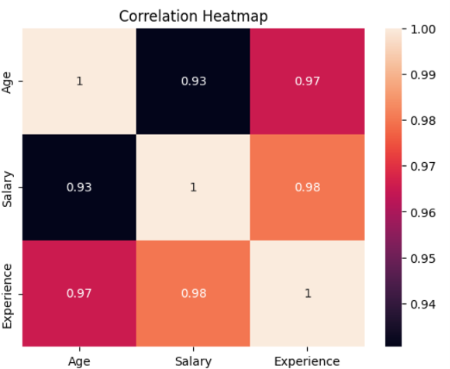
Interpretation
The heatmap shows the correlation between Age, Salary and Experience.
Correlation values are between:
-1 and +1
- +1 → Strong positive relationship
- 0 → No linear relationship
-1 → Strong negative relationship
- 6. Pairplot

Description
- A pairplot creates relationships between multiple numerical variables.
- sns.pairplot(
- df[["Age", "Salary", "Experience"]]
- )

- plt.show()
- Interpretation
- Pairplot helps us visually examine relationships between Age, Salary and Experience.

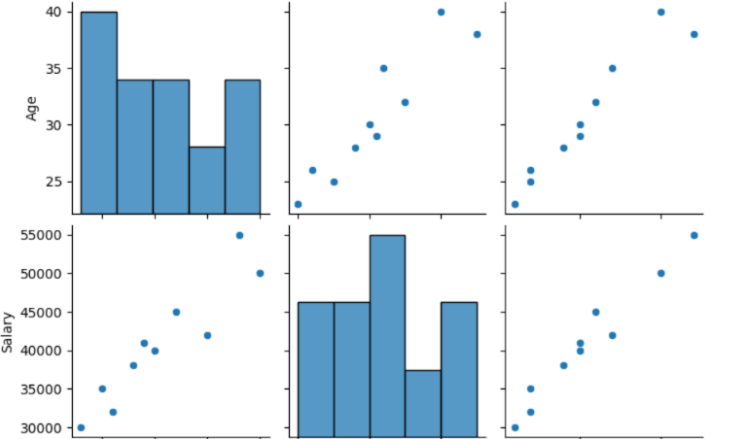

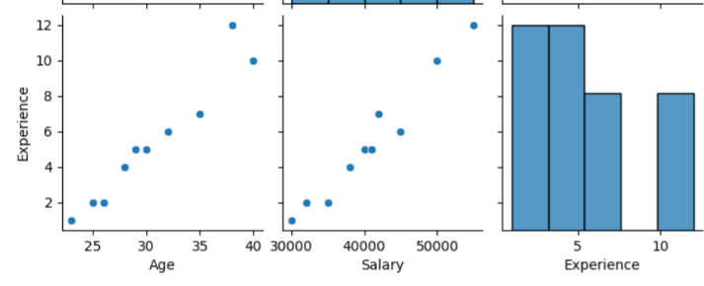
7. Distribution Plot
Description
A distribution plot shows how numerical values are distributed.
sns.histplot(
df["Salary"],
kde=True
)
plt.title("Salary Distribution")
plt.xlabel("Salary")
plt.ylabel("Frequency")
plt.show()
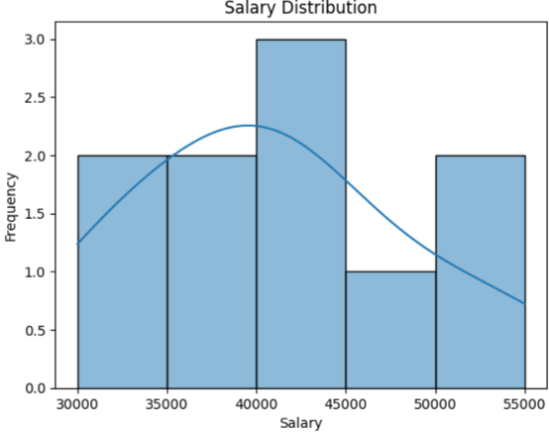
Interpretation
The chart shows the distribution of employee salaries and the general shape of the data.
REQUIRED EDA
The task specifically requires these five analyses: distribution analysis, category analysis, outlier analysis, correlation heatmap and pairplot, followed by 5–10 observations.
1. Distribution Analysis
sns.histplot(df["Salary"], kde=True)
plt.title("Salary Distribution")
plt.xlabel("Salary")
plt.ylabel("Frequency")
plt.show()
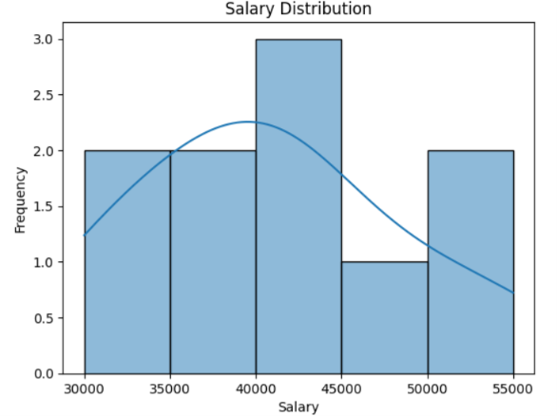
Observation
Salary values are distributed across different salary ranges. The KDE curve helps visualize the overall distribution shape.
2. Category Analysis
sns.countplot(x="Department", data=df)
plt.title("Employee Count by Department")
plt.xlabel("Department")
plt.ylabel("Employee Count")
plt.show()
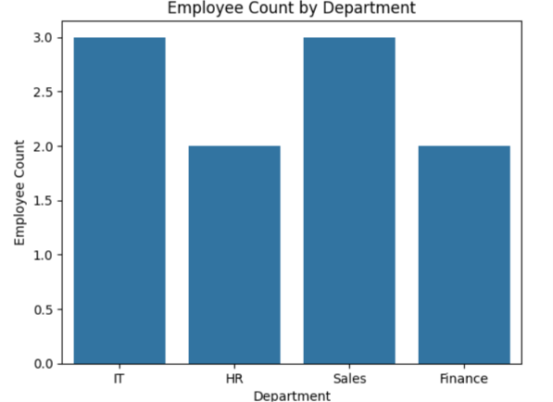
Observation
The countplot allows us to compare the number of employees across departments.

3. Outlier Analysis
sns.boxplot(y=df["Salary"])
plt.title("Salary Outlier Analysis")
plt.ylabel("Salary")
plt.show()
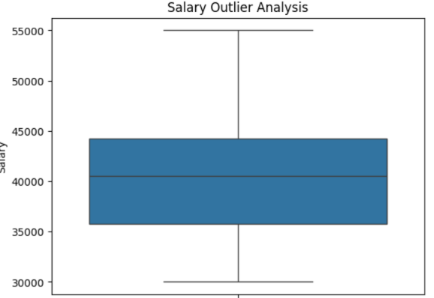
Observation
The boxplot shows the median, quartiles and possible extreme salary values.

4. Correlation Heatmap
corr = df[["Age", "Salary", "Experience"]].corr()
sns.heatmap(
corr,
annot=True
)
plt.title("Correlation Heatmap")
plt.show()
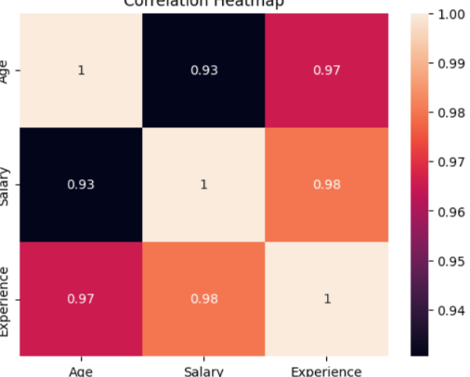
Observation
The heatmap helps identify whether numerical variables move together.

5. Pairplot
sns.pairplot(
df[["Age", "Salary", "Experience"]]
)
plt.show()
Observation
The pairplot provides a visual overview of relationships between all selected numerical variables.

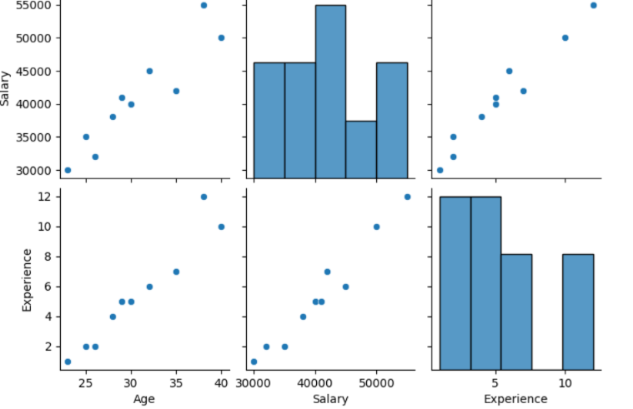

DAY 13 — POWER BI
Date:-25/09/2026
Complete Task with Short Description, Steps & Examples
The original task requires you to learn data import, Power Query, transformation, data types, filters, slicers, charts, cards, tables, and matrix, then create a one-page sales dashboard containing six required analyses.

1. Import Data
Description
Importing data means bringing a CSV/Excel/database file into Power BI for analysis.
Steps
- Open Power BI Desktop.
- Click Home → Get Data.
- Select Text/CSV.
- Select your Data13.csv file.
- Click Load.
Example
Your table name is:
Data13

2. Power Query
Description
Power Query is used to clean and prepare data before creating the dashboard.
Steps
Home
↓
Transform Data
↓
Power Query Editor
Common operations
- Remove duplicate rows
- Remove blank rows
- Rename columns
- Change data types
- Replace incorrect values
- Filter rows
Example
If Sales is imported as text:
Sales → Data Type → Decimal Number

3. Transform Data
Description
Data transformation means changing raw data into a useful format for analysis.
Example
You can:
Rename column
Remove unwanted column
Change data type
Replace values
Remove duplicates
Steps
Transform Data → select column → choose required transformation

4. Data Types
Description
Data type tells Power BI what kind of data a column contains.
For your Data13:
Column | Data Type
Order_ID | Whole Number
Order_Date | Date
Customer_ID | Text
Product | Text
Category | Text
Region | Text
Quantity | Whole Number
Unit_Price | Decimal Number
Sales | Decimal Number
Cost | Decimal Number
Profit | Decimal Number

5. Filters
Description
A filter displays only the data that matches a selected condition.
Example
If you select:
Region = West
the visual will show only West-region data.
Types
- Visual-level filter
- Page-level filter
- Report-level filter

6. Slicers
Description
A slicer is an interactive filter that users can click on the dashboard.
Example
Create a slicer using:
Region
It will show:
North
South
East
West
When you select West, the dashboard updates automatically.
Recommended slicers
- Region
- Category
- Order_Date

7. Charts
Description
Charts represent data visually and make comparisons easier.
For your dashboard:
Requirement | Chart
Sales by Category | Column Chart
Sales by Region | Bar Chart
Monthly Sales | Line Chart

8. Cards
Description
A Card displays a single important KPI.
Use Cards for:
- Total Sales
- Total Orders
- Total Customers
- Total Profit
- Average Order Value
- Profit Margin
Example:
┌─────────────────┐
│ ₹992,000 │
│ Total Sales │
└─────────────────┘

9. Tables
Description
A table displays detailed data in rows and columns.
Example
Order ID | Category | Region | Sales | Profit
10001 | Electronics | North | 55000 | 15400
10002 | Furniture | South | 16000 | 5120
Use
Use a table when you want to see individual records.

10. Matrix
Description
A Matrix is similar to a table but can summarize data using rows and columns.
Example
Region | Electronics | Furniture | Groceries
North | ₹... | ₹... | ₹...
South | ₹... | ₹... | ₹...
East | ₹... | ₹... | ₹...
West | ₹... | ₹... | ₹...

11. Total Sales
Description
Total Sales calculates the total amount of sales.
DAX
Total Sales =
SUM(Data13[Sales])
Visual
Card

12. Total Orders
Description
Counts unique orders.
DAX
Total Orders =
DISTINCTCOUNT(Data13[Order_ID])
Visual
Card

13. Total Customers
Description
Counts unique customers.
DAX
Total Customers =
DISTINCTCOUNT(Data13[Customer_ID])
Visual
Card

14. Sales by Category
Description
Shows how much sales each category generated.
Measure
Total Sales =
SUM(Data13[Sales])
Chart
Column Chart
Fields
X-Axis → Category
Y-Axis → Total Sales

15. Sales by Region
Description
Compares sales between different regions.
Chart
Bar Chart
Fields
Y-Axis → Region
X-Axis → Total Sales
Use the same measure:
Total Sales =
SUM(Data13[Sales])

16. Monthly Sales
Description
Shows how sales change month by month.
Step 1 — Create Month
Go to New Column:
Month =
FORMAT(Data13[Order_Date], "MMM")
Step 2 — Create Month Number
Month Number =
MONTH(Data13[Order_Date])
Step 3 — Sort Month
Select:
Month
→ Column tools
→ Sort by column
→ Month Number
Step 4 — Create Chart
Use Line Chart.
X-Axis → Month
Y-Axis → Total Sales
Day 13 Deliverable
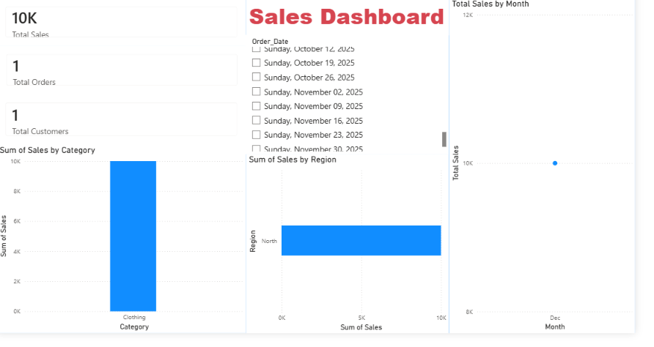

DAY 14 — DAX
Date:-25/09/2026
The Day 14 task requires six main measures and practice with CALCULATE, FILTER, ALL, SUMX, COUNTROWS, and DISTINCTCOUNT, with at least 8 measures in the final dashboard.

18. What is DAX?
Description
DAX = Data Analysis Expressions
DAX is the formula language used in Power BI to create calculations and measures.
Example
Total Sales =
SUM(Data13[Sales])
DAX measures can respond dynamically to filters and slicers.

19. Total Revenue
Your Data13 file has a Sales column, so Sales is used as Revenue.
DAX
Total Revenue =
SUM(Data13[Sales])
Description
Calculates the total revenue generated from all sales.

20. Total Profit
DAX
Total Profit =
SUM(Data13[Profit])
Description
Calculates the total profit.

21. Total Orders
Total Orders =
DISTINCTCOUNT(Data13[Order_ID])
Description
Counts unique orders.

22. Total Customers
Total Customers =
DISTINCTCOUNT(Data13[Customer_ID])
Description
Counts unique customers.

23. Average Order Value
Description
Shows the average sales amount per order.
DAX
Average Order Value =
DIVIDE(
[Total Sales],
[Total Orders],
0
)
Formula
Average Order Value = Total Sales ÷ Total Orders
Visual
Card

24. Profit Margin
Description
Shows profit as a percentage of sales.
DAX
Profit Margin =
DIVIDE(
[Total Profit],
[Total Sales],
0
)
Then:
Measure tools → Format → Percentage (%)
Formula
Profit Margin = Total Profit ÷ Total Sales

25. CALCULATE
Description
CALCULATE() changes the filter context of a calculation.
Example
West Sales =
CALCULATE(
[Total Sales],
Data13[Region] = "West"
)
Meaning
Calculates sales only for the West region.

26. FILTER
Description
FILTER() returns rows that satisfy a condition.
Example
High Value Sales =
CALCULATE(
[Total Sales],
FILTER(
Data13,
Data13[Sales] > 10000
)
)
Meaning
Calculates sales for records where Sales is greater than ₹10,000.

27. ALL
Description
ALL() removes filters from a column or table.
Example
All Region Sales =
CALCULATE(
[Total Sales],
ALL(Data13[Region])
)
Meaning
Calculates sales without applying the Region filter.

28. SUMX
Description
SUMX() performs a calculation for each row and then adds the results.
Example
Total Value =
SUMX(
Data13,
Data13[Quantity] * Data13[Unit_Price]
)
Meaning
For every record:
Quantity × Unit Price
Then all calculated values are added.

29. COUNTROWS
Description
COUNTROWS() counts the number of rows in a table.
DAX
Number of Rows =
COUNTROWS(Data13)
Meaning
Returns the number of records in Data13.

30. DISTINCTCOUNT
Description
DISTINCTCOUNT() counts unique values.
Example
Unique Customers =
DISTINCTCOUNT(Data13[Customer_ID])
Meaning
If one customer has multiple orders, the customer is still counted only once.

31. Final 8+ DAX Measures
Create these measures for your Day 14 task:
1. Total Sales
Total Sales =
SUM(Data13[Sales])
2. Total Revenue
Total Revenue =
SUM(Data13[Sales])
3. Total Profit
Total Profit =
SUM(Data13[Profit])
4. Total Orders
Total Orders =
DISTINCTCOUNT(Data13[Order_ID])
5. Total Customers
Total Customers =
DISTINCTCOUNT(Data13[Customer_ID])
6. Average Order Value
Average Order Value =
DIVIDE(
[Total Sales],
[Total Orders],
0
)
7. Profit Margin
Profit Margin =
DIVIDE(
[Total Profit],
[Total Sales],
0
)
8. West Sales
West Sales =
CALCULATE(
[Total Sales],
Data13[Region] = "West"
)
9. High Value Sales
High Value Sales =
CALCULATE(
[Total Sales],
FILTER(
Data13,
Data13[Sales] > 10000
)
)
10. All Region Sales
All Region Sales =
CALCULATE(
[Total Sales],
ALL(Data13[Region])
)
This gives you 10 measures, which is more than the required minimum of 8.

32. Day 14 Dashboard
Use Cards for:
Total Revenue
Total Profit
Total Orders
Total Customers
Average Order Value
Profit Margin
Use charts for:
Sales by Category
Sales by Region
Monthly Sales
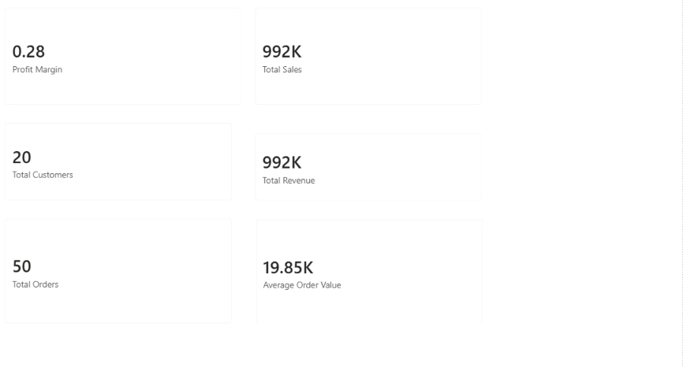

DAY 15 — Git & GitHub
Date:-26/09/2026
Task
Learn Git and GitHub and understand the basic commands used to manage and share projects.
The PDF requires you to learn Repository, Clone, Commit, Push, Pull, Branch, Merge, .gitignore, and README, then create a repository named data-internship-username and upload Days 1–14.

1. Git
Description
Git is a version control system used to track changes in files and source code.
It helps developers:
- Track changes
- Restore previous versions
- Work on projects safely
- Collaborate with other developers
Example
Suppose you have:
project.py
You modify it today and again tomorrow.
Git keeps track of these changes.

2. GitHub
Description
GitHub is an online platform where Git repositories can be stored and shared.
Git manages your project locally, while GitHub can store your repository online.
Example
Computer
↓
Git
↓
GitHub
↓
Online Repository

3. Repository
Description
A repository (repo) is a project folder managed by Git.
It contains:
- Project files
- Code
- Documentation
- Git history
Example
data-internship-username/
│
├── Day01/
├── Day02/
├── Day03/
├── ...
├── Day14/
└── README.md

4. Clone
Description
Clone downloads an existing GitHub repository to your computer.
Command
git clone https://github.com/username/repository.git
Example
git clone https://github.com/indrajit/data-internship-username.git
Meaning
It creates a local copy of the GitHub repository.

5. Commit
Description
A commit saves a set of changes in Git history.
Command
git add .
git commit -m "Added Day 1 to Day 5 tasks"
Meaning
- git add . → selects changes
- git commit → saves the changes in Git history

6. Push
Description
Push uploads your local commits to GitHub.
Command
git push
Example
Local Computer
↓
git push
↓
GitHub

7. Pull
Description
Pull downloads the latest changes from GitHub to your local repository.
Command
git pull
Example
If someone updates the GitHub repository, you can get the latest changes using:
git pull

8. Branch
Description
A branch is a separate line of development.
It allows you to work on a feature without directly changing the main branch.
Create branch
git branch feature-dashboard
Switch to branch
git checkout feature-dashboard
Or:
git switch feature-dashboard
Example
main
│
├── feature-dashboard
│
└── feature-login

9. Merge
Description
Merge combines changes from one branch into another branch.
Example
Suppose you worked on:
feature-dashboard
After completing it, you want to merge it into main.
Commands
git switch main
git merge feature-dashboard

10. .gitignore
Description
.gitignore tells Git which files or folders should not be uploaded to the repository.
Example
Create:
.gitignore
Add:
__pycache__/
*.pyc
.env
venv/
Why?
You should not upload unnecessary files or private configuration files.

11. README
Description
README.md explains what your project is about.
It normally contains:
- Project name
- Project description
- Technologies used
- Installation steps
- How to run the project
- Author information
Example
# Data Internship

This repository contains my Data Analyst and Data Science
internship tasks from Day 1 to Day 14.

## Technologies

- Python
- SQL
- Pandas
- Power BI
- DAX
## Author
Indrajit

12. Create the GitHub Repository
The task requires the repository name:
data-internship-username
For example:
data-internship-indrajit
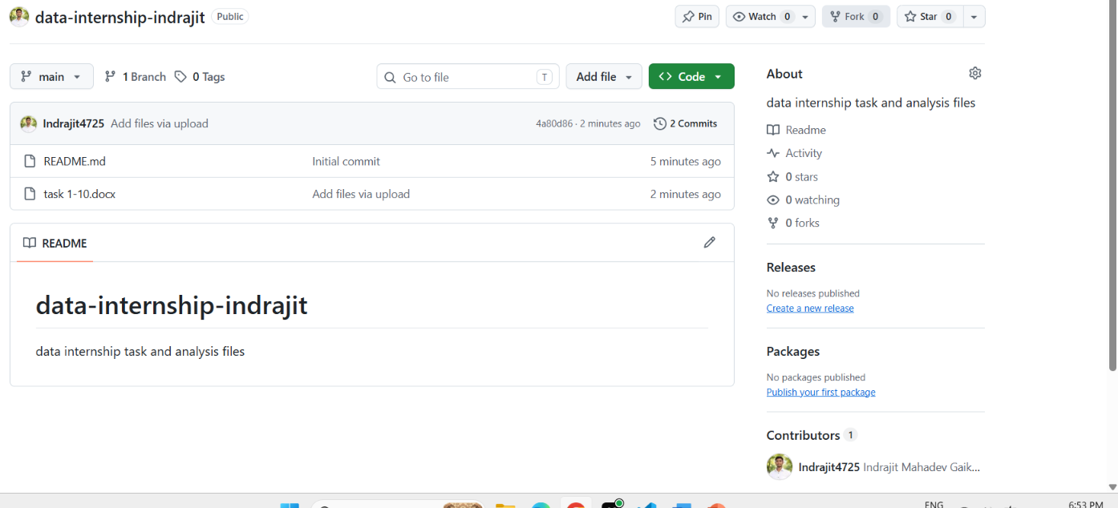

DAY 16 — MACHINE LEARNING FUNDAMENTALS
Date:-26/09/2026
Q1. What is Artificial Intelligence (AI)?
Answer
Artificial Intelligence (AI) is a field of computer science that focuses on developing systems capable of performing tasks that normally require human intelligence.
AI systems can process information, recognize patterns, understand language, and support decision-making.
Examples
- Chatbots
- Voice assistants
- Image recognition
- Recommendation systems

Q2. What is Machine Learning (ML)?
Answer
Machine Learning (ML) is a subset of Artificial Intelligence in which computers learn patterns from data and use those patterns to make predictions or decisions.
Instead of explicitly programming every rule, we provide data and an appropriate learning algorithm.
Example
Historical House Data
↓
Machine Learning Model
↓
Predicted House Price
Applications
- Sales prediction
- Fraud detection
- Customer churn prediction
- Recommendation systems

Q3. What is Deep Learning?
Answer
Deep Learning is a subset of Machine Learning that uses multi-layered artificial neural networks to learn complex patterns from data.
Applications
- Image recognition
- Speech recognition
- Natural language processing
- Computer vision
Relationship
Artificial Intelligence
↓
Machine Learning
↓
Deep Learning

Q4. What is Supervised Learning?
Answer
Supervised Learning is a machine-learning approach in which the model is trained using labeled data. The training dataset contains both input features and a known target/output.
Example
Study Hours + Attendance
↓
ML Model
↓
Final Marks
Here, Study Hours and Attendance are features, while Final Marks is the target.
Main types
- Regression
- Classification

Q5. What is Unsupervised Learning?
Answer
Unsupervised Learning is a machine-learning approach where the training data does not contain a predefined target. The model identifies patterns, structures, or groups within the data.
Example
Customer Data
↓
Clustering Algorithm
↓
Customer Groups
Common application
Customer segmentation

Q6. What is Regression?
Answer
Regression is a supervised learning technique used to predict a continuous numerical value.
Examples
- House price prediction
- Salary prediction
- Sales prediction
- Temperature prediction
Example
Area + Bedrooms + Location
↓
House Price
Common algorithms
- Linear Regression
- Decision Tree Regressor
- Random Forest Regressor

Q7. What is Classification?
Answer
Classification is a supervised learning technique used to predict a category or class.
Examples
Email → Spam / Not Spam
Loan → Approved / Rejected
Customer → Churn / No Churn
Common algorithms
- Logistic Regression
- Decision Tree
- Random Forest
- K-Nearest Neighbors
- Support Vector Machine

Q8. What is Clustering?
Answer
Clustering is an unsupervised learning technique used to group similar data points together without predefined labels.
Example
Customer Data
↓
K-Means Clustering
↓
Group 1
Group 2
Group 3
Common algorithm
K-Means Clustering

Q9. What is the difference between Supervised and Unsupervised Learning?
Supervised Learning | Unsupervised Learning
Uses labeled data | Uses data without predefined target
Has a target variable | No predefined target
Used for prediction | Used for finding patterns/groups
Regression and Classification | Clustering
Example: House price prediction | Example: Customer segmentation

Q10. What is the difference between Regression and Classification?
Regression | Classification
Predicts a numerical value | Predicts a category
Continuous output | Categorical output
Example: Salary | Example: Loan approval
Example: House price | Example: Spam detection
Linear Regression is common | Logistic Regression is common

Q11. What are Features?
Answer
Features are the input variables used by a machine-learning model to make a prediction.
Example
For house-price prediction:
Area
Bedrooms
Location
Bathrooms
These are the features.

Q12. What is a Target?
Answer
The target is the output variable that a supervised machine-learning model is trained to predict.
Example
Features:
Area
Bedrooms
Location

Target:
House Price

Q13. What is an Algorithm?
Answer
A machine-learning algorithm is a mathematical or computational method used to learn patterns from data and generate predictions or groupings.
Examples
- Linear Regression
- Logistic Regression
- Decision Tree
- Random Forest
- K-Means

Q14. Real-World Problem 1 — House Price Prediction
Problem
Predict the selling price of a house.
Type
Supervised Learning → Regression
Features
- Area
- Number of bedrooms
- Location
- Bathrooms
Target
House Price
Possible Algorithms
- Linear Regression
- Random Forest Regressor
Example
Area + Bedrooms + Location
↓
House Price

Q15. Real-World Problem 2 — Email Spam Detection
Problem
Determine whether an email is spam or not.
Type
Supervised Learning → Classification
Features
- Email text
- Number of links
- Keywords
- Sender information
Target
Spam / Not Spam
Possible Algorithms
- Naive Bayes
- Logistic Regression
- Random Forest

Q16. Real-World Problem 3 — Customer Segmentation
Problem
Group customers according to their purchasing behavior.
Type
Unsupervised Learning → Clustering
Features
- Age
- Income
- Purchase amount
- Purchase frequency
Target
No predefined target
Possible Algorithm
K-Means Clustering
Example
Customer Data
↓
K-Means
↓
Customer Groups

Q17. Real-World Problem 4 — Student Marks Prediction
Problem
Predict a student's final marks.
Type
Supervised Learning → Regression
Features
- Study hours
- Attendance
- Previous marks
- Assignment scores
Target
Final Marks
Possible Algorithms
- Linear Regression
- Random Forest Regressor

Q18. Real-World Problem 5 — Customer Churn Prediction
Problem
Predict whether a customer will leave a service.
Type
Supervised Learning → Classification
Features
- Customer tenure
- Monthly charges
- Contract type
- Usage
- Age
Target
Churn / No Churn
Possible Algorithms
- Logistic Regression
- Decision Tree
- Random Forest

Q19. Real-World Problem 6 — Sales Prediction
Problem
Predict future sales based on historical business data.
Type
Supervised Learning → Regression
Features
- Previous sales
- Price
- Quantity
- Discount
- Month
Target
Future Sales
Possible Algorithms
- Linear Regression
- Random Forest Regressor

Q20. Real-World Problem 7 — Loan Approval Prediction
Problem
Predict whether a loan application belongs to an approved or rejected class using historical labeled applications.
Type
Supervised Learning → Classification
Features
- Income
- Credit history
- Loan amount
- Employment status
- Age
Target
Approved / Rejected
Possible Algorithms
- Logistic Regression
- Decision Tree
- Random Forest

Q21. Real-World Problem 8 — Customer Grouping
Problem
Group customers with similar purchasing behavior.
Type
Unsupervised Learning → Clustering
Features
- Purchase frequency
- Purchase amount
- Product categories
Target
No predefined target
Possible Algorithm
K-Means Clustering

Q22. Real-World Problem 9 — Employee Salary Prediction
Problem
Predict an employee's salary based on relevant employee and job characteristics.
Type
Supervised Learning → Regression
Features
- Experience
- Education
- Skills
- Job role
- Location
Target
Salary
Possible Algorithms
- Linear Regression
- Random Forest Regressor

Q23. Real-World Problem 10 — Disease Classification
Problem
Classify a medical case into predefined classes using available labeled data.
Type
Supervised Learning → Classification
Features
- Age
- Symptoms
- Test results
- Blood pressure
- Other measured variables
Target
Disease Class
Possible Algorithms
- Logistic Regression
- Decision Tree
- Random Forest

Q24. Complete 10-Problem Summary
No. | Problem | Type | Features | Target | Algorithm
1 | House Price Prediction | Regression | Area, Bedrooms, Location | House Price | Linear Regression
2 | Spam Detection | Classification | Email Text, Links, Keywords | Spam/Not Spam | Naive Bayes
3 | Customer Segmentation | Clustering | Age, Income, Purchases | None | K-Means
4 | Student Marks | Regression | Study Hours, Attendance | Final Marks | Linear Regression
5 | Customer Churn | Classification | Tenure, Charges, Usage | Churn/No Churn | Random Forest
6 | Sales Prediction | Regression | Previous Sales, Price, Quantity | Future Sales | Linear Regression
7 | Loan Approval | Classification | Income, Credit History, Loan Amount | Approved/Rejected | Decision Tree
8 | Customer Grouping | Clustering | Purchase Frequency, Amount | None | K-Means
9 | Salary Prediction | Regression | Experience, Education, Skills | Salary | Random Forest
10 | Disease Classification | Classification | Age, Symptoms, Test Results | Disease Class | Logistic Regression

Q25. What is the Machine Learning Workflow?
Answer
A basic machine-learning workflow is:
1. Define the Problem
↓
2. Collect Data
↓
3. Clean and Prepare Data
↓
4. Select Features and Target
↓
5. Split Data
↓
6. Select Algorithm
↓
7. Train Model
↓
8. Evaluate Model
↓
9. Make Predictions
↓
10. Deploy/Use Model
Example
For house-price prediction:
House Dataset
↓
Clean Data
↓
Select Features
↓
Train Regression Model
↓
Evaluate
↓
Predict House Price

DAY 17 — MACHINE LEARNING ALGORITHMS
Date:-28/09/2026
1. What is Machine Learning?
Description
Machine Learning is a branch of Artificial Intelligence that allows computers to learn patterns from data and use those patterns to make predictions or decisions.
Example
Historical Data
↓
Machine Learning Algorithm
↓
Learn Patterns
↓
Prediction

2. Regression
Description
Regression is a supervised machine-learning technique used to predict a continuous numerical value.
Examples
- House price prediction
- Salary prediction
- Sales prediction
- Temperature prediction
Example
Area + Bedrooms + Location
↓
Regression Model
↓
House Price
Output
₹50,00,000
The output is a numerical value.

3. Linear Regression
Description
Linear Regression is a regression algorithm that models the relationship between input variables and a continuous target.
Basic Formula
y = mx + c
Where:
- y = predicted value
- x = input
- m = coefficient/slope
- c = intercept
Example
Predict salary based on years of experience.
Experience → Salary
2 years → ₹30,000
5 years → ₹55,000
8 years → ₹80,000
Python Example
from sklearn.linear_model import LinearRegression

model = LinearRegression()

model.fit(X_train, y_train)

y_pred = model.predict(X_test)

print(y_pred)
Advantages
- Simple to understand
- Easy to implement
- Fast for suitable datasets

4. Decision Tree Regression
Description
A Decision Tree Regressor predicts numerical values by splitting the data into smaller groups based on feature conditions.
Example
Experience > 5?
/ \
Yes No
↓ ↓
Higher Lower
Salary Salary
Python
from sklearn.tree import DecisionTreeRegressor

model = DecisionTreeRegressor(random_state=42)

model.fit(X_train, y_train)

y_pred = model.predict(X_test)

print(y_pred)
Advantages
- Easy to understand
- Can capture nonlinear relationships
- Does not require feature scaling in many cases

5. Random Forest Regression
Description
Random Forest Regressor combines multiple decision trees and uses their predictions to produce a final numerical prediction.
Concept
Dataset
↓
Tree 1 ──→ Prediction
Tree 2 ──→ Prediction
Tree 3 ──→ Prediction
Tree 4 ──→ Prediction
↓
Combined Result
↓
Final Prediction
Python
from sklearn.ensemble import RandomForestRegressor

model = RandomForestRegressor(
n_estimators=100,
random_state=42
)

model.fit(X_train, y_train)

y_pred = model.predict(X_test)

print(y_pred)

6. Classification
Description
Classification is a supervised machine-learning technique used to predict a category or class.
Examples
Email → Spam / Not Spam
Loan → Approved / Rejected
Customer → Churn / No Churn
Unlike regression, classification does not predict a continuous numerical value as the final class output.

7. Logistic Regression
Description
Logistic Regression is a classification algorithm commonly used for predicting class probabilities and class labels.
Example
Customer Data
↓
Logistic Regression
↓
Churn / No Churn
Python
from sklearn.linear_model import LogisticRegression

model = LogisticRegression(max_iter=1000)

model.fit(X_train, y_train)

y_pred = model.predict(X_test)

print(y_pred)
Applications
- Spam detection
- Churn prediction
- Binary classification

8. Decision Tree Classification
Description
A Decision Tree Classifier predicts a class by making a sequence of decisions based on feature values.
Example
Income > 50000?
/ \
Yes No
↓ ↓
Approved Rejected
Python
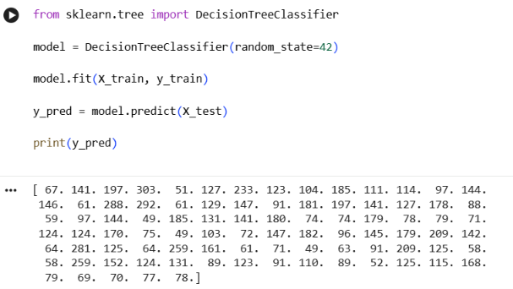
9. Random Forest Classification
Description
Random Forest Classifier combines multiple decision trees to make a classification prediction.
Concept
Dataset
↓
┌─────────┼─────────┐
↓ ↓ ↓
Tree 1 Tree 2 Tree 3
↓ ↓ ↓
Class A Class B Class A
└─────────┼─────────┘
↓
Final Class
Python
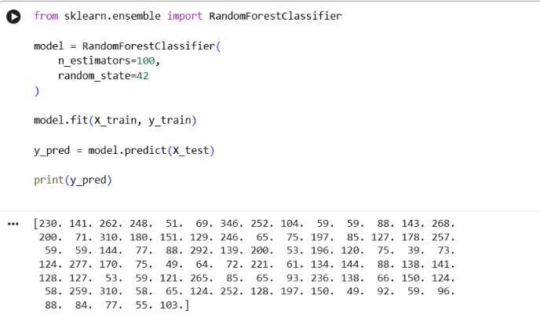
10. K-Nearest Neighbors — KNN
Description
KNN classifies a data point based on the classes of its nearest neighboring data points.
Example
If most of the nearest neighbors belong to Class A, the new data point may be classified as Class A.
New Point
↓
Find nearest K points
↓
Check their classes
↓
Assign class
Python
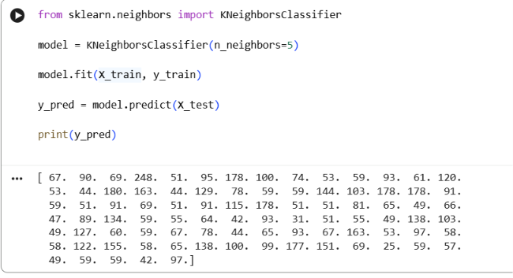
11. Clustering
Description
Clustering is an unsupervised learning technique that groups similar data points together.
Unlike supervised learning, clustering does not require a predefined target label.
Example
Customer Data
↓
Clustering
↓
Group 1
Group 2
Group 3

12. K-Means Clustering
Description
K-Means is a clustering algorithm that divides data into a specified number of clusters.
The number of clusters is represented by K.
Example
If:
K = 3
the algorithm creates three clusters.
Python
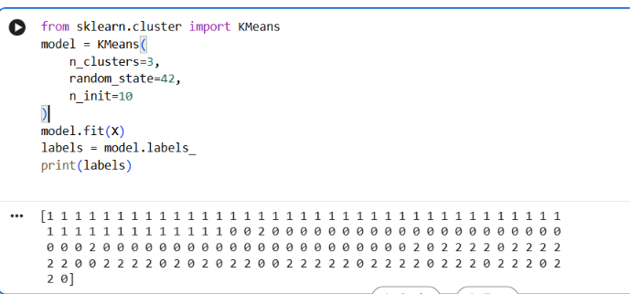
13. Difference Between Regression and Classification
Point | Regression | Classification
Purpose | Predict numerical values | Predict classes
Learning | Supervised | Supervised
Output | Continuous value | Category/class
Example | House price | Spam detection
Example output | ₹50,00,000 | Spam
Algorithms | Linear Regression, Random Forest Regressor | Logistic Regression, Decision Tree

14. Difference Between Classification and Clustering
Point | Classification | Clustering
Learning type | Supervised | Unsupervised
Target | Predefined | No predefined target
Purpose | Predict classes | Discover groups
Data | Labeled | Unlabeled
Example | Spam detection | Customer segmentation
Algorithm | Logistic Regression | K-Means

15. Day 17 — Required Models
The PDF requires at least:
2 Regression Models
1. Linear Regression
2. Decision Tree / Random Forest Regression
2 Classification Models
1. Logistic Regression
2. Decision Tree / Random Forest / KNN
1 Clustering Model
1. K-Means
This directly satisfies the Day 17 model-training requirement.

16. Complete Example — Regression
Here is a simple example using the built-in Diabetes dataset available in scikit-learn.
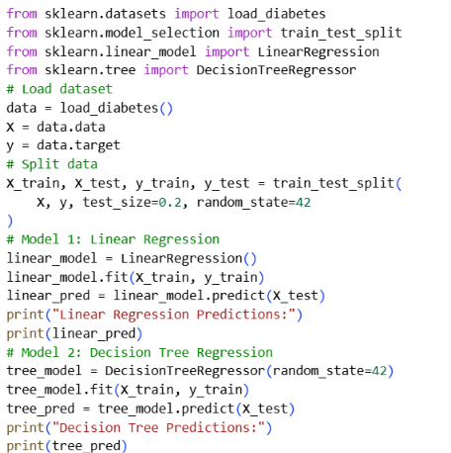Result
You have trained:
Model 1 → Linear Regression
Model 2 → Decision Tree Regression

17. Complete Example — Classification
Use the Iris dataset.
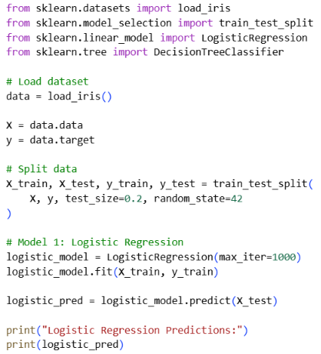
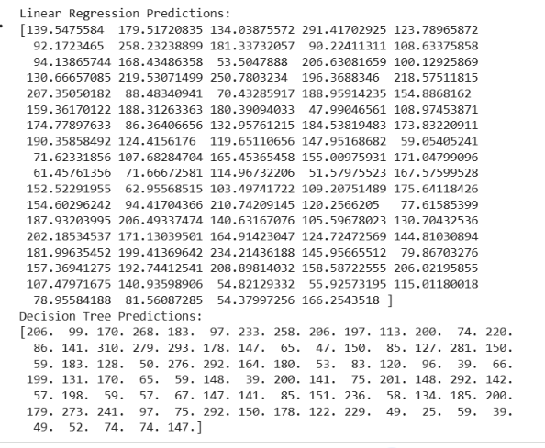
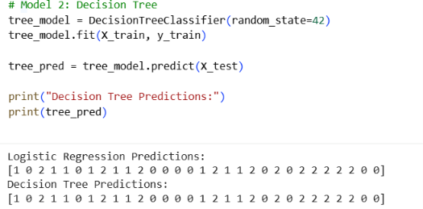
Result
You have trained:
Model 1 → Logistic Regression
Model 2 → Decision Tree Classifier

18. Complete Example — K-Means Clustering
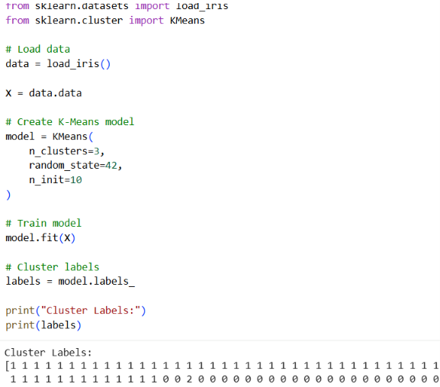
Result
The data is divided into:
Cluster 0
Cluster 1
Cluster 2

20. Conclusion
In Day 17, we learned three important machine-learning approaches:
Approach | Purpose | Example Algorithm
Regression | Predict numerical values | Linear Regression
Classification | Predict classes | Logistic Regression
Clustering | Find groups in data | K-Means

DAY 18 — MODEL EVALUATION
Date:-28/09/2026
Professional Task Description
Objective
The objective of Day 18 is to learn how to evaluate the performance of Machine Learning models using appropriate evaluation metrics.
A machine-learning model is not useful only because it generates predictions. Its performance must be measured using suitable evaluation metrics.

PART A — REGRESSION EVALUATION
Regression models predict continuous numerical values, such as house prices, sales, salary, or temperature.
The following metrics are used to evaluate regression models:
- MAE
- MSE
- RMSE
- R² Score

1. MAE — Mean Absolute Error
Description
Mean Absolute Error (MAE) measures the average absolute difference between the actual values and predicted values.
Formula
MAE=1n∑∣yi−yi^∣MAE = \frac{1}{n}\sum |y_i-\hat{y_i}|
Where:
- y = Actual value
- ŷ = Predicted value
- n = Number of observations
Example
Actual:
[100, 200, 300]
Predicted:
[110, 190, 310]
The prediction errors are:
10, 10, 10
Therefore:
MAE = 10
Interpretation
Lower MAE indicates smaller average prediction errors.
Python
from sklearn.metrics import mean_absolute_error
mae = mean_absolute_error(y_test, y_pred)
print("MAE:", mae)

2. MSE — Mean Squared Error
Description
Mean Squared Error (MSE) calculates the average of the squared differences between actual and predicted values.
Formula
MSE=1n∑(yi−yi^)2MSE = \frac{1}{n}\sum(y_i-\hat{y_i})^2
Python
from sklearn.metrics import mean_squared_error

mse = mean_squared_error(y_test, y_pred)

print("MSE:", mse)
Interpretation
- Lower MSE = better performance
- Large errors receive more penalty because errors are squared.

3. RMSE — Root Mean Squared Error
Description
Root Mean Squared Error (RMSE) is the square root of MSE.
Formula
RMSE=MSERMSE = \sqrt{MSE}
Python
import numpy as np
from sklearn.metrics import mean_squared_error

mse = mean_squared_error(y_test, y_pred)
rmse = np.sqrt(mse)

print("RMSE:", rmse)
Interpretation
A lower RMSE generally indicates better prediction performance.
Because RMSE is expressed in the same units as the target, it is often easier to interpret than MSE.

4. R² — R-Squared Score
Description
R² (R-Squared) measures how much of the variation in the target variable is explained by the regression model.
Formula
R2=1−SSresSStotR^2 = 1-\frac{SS_{res}}{SS_{tot}}
Python
from sklearn.metrics import r2_score

r2 = r2_score(y_test, y_pred)

print("R² Score:", r2)
Interpretation
A value closer to 1 generally indicates that the model explains more of the variation in the target data.

PART B — CLASSIFICATION EVALUATION
Classification models predict categories or classes such as:
Spam / Not Spam
Pass / Fail
Approved / Rejected
The main evaluation metrics are:
- Accuracy
- Precision
- Recall
- F1 Score
- Confusion Matrix
- ROC-AUC

5. Accuracy
Description
Accuracy measures the proportion of all predictions that are correct.
Formula
Accuracy=TP+TNTP+TN+FP+FNAccuracy = \frac{TP+TN}{TP+TN+FP+FN}
Where:
- TP = True Positive
- TN = True Negative
- FP = False Positive
- FN = False Negative
Python
from sklearn.metrics import accuracy_score

accuracy = accuracy_score(y_test, y_pred)

print("Accuracy:", accuracy)
Interpretation
Higher accuracy means a larger proportion of predictions are correct.

6. Precision
Description
Precision measures how many of the observations predicted as positive were actually positive.
Formula
Precision=TPTP+FPPrecision = \frac{TP}{TP+FP}
Python
from sklearn.metrics import precision_score

precision = precision_score(
y_test,
y_pred,
average="weighted"
)

print("Precision:", precision)
Example
If a model predicts 100 customers as positive and 90 are actually positive:
Precision = 90 / 100 = 0.90
So precision is 90%.

7. Recall
Description
Recall measures how many of the actual positive observations were correctly identified by the model.
Formula
Recall=TPTP+FNRecall = \frac{TP}{TP+FN}
Python
from sklearn.metrics import recall_score

recall = recall_score(
y_test,
y_pred,
average="weighted"
)

print("Recall:", recall)
Interpretation
Higher recall means the model identifies a larger proportion of actual positive cases.

8. F1 Score
Description
F1 Score combines Precision and Recall into a single metric using their harmonic mean.
Formula
F1=2×Precision×RecallPrecision+RecallF1 = 2\times\frac{Precision\times Recall} {Precision+Recall}
Python
from sklearn.metrics import f1_score

f1 = f1_score(
y_test,
y_pred,
average="weighted"
)

print("F1 Score:", f1)
Interpretation
A higher F1 Score indicates a better balance between precision and recall.

9. Confusion Matrix
Description
A Confusion Matrix shows the number of correct and incorrect classification predictions.
For binary classification:
 | Predicted Positive | Predicted Negative
Actual Positive | TP | FN
Actual Negative | FP | TN
Python
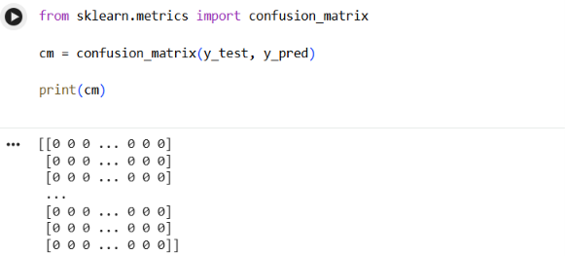
Visualization
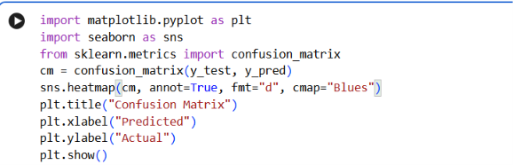
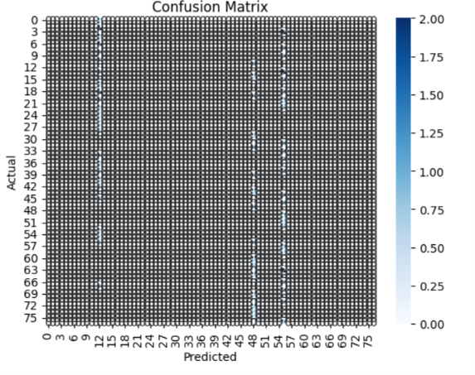

10. ROC-AUC
Description
ROC-AUC evaluates how well a classification model separates different classes.
- ROC = Receiver Operating Characteristic
- AUC = Area Under the Curve
ROC uses:
- True Positive Rate
- False Positive Rate
Python
For binary classification:
from sklearn.metrics import roc_auc_score

y_probability = model.predict_proba(X_test)[:, 1]

roc_auc = roc_auc_score(y_test, y_probability)

print("ROC-AUC:", roc_auc)
Interpretation
A higher ROC-AUC generally indicates better class-separation ability.
For multiclass problems, the calculation must use an appropriate multiclass configuration.

11. Regression Metrics — Summary
Metric | Full Form | Measures | Better Direction
MAE | Mean Absolute Error | Average absolute error | Lower
MSE | Mean Squared Error | Average squared error | Lower
RMSE | Root Mean Squared Error | Typical prediction error magnitude | Lower
R² | R-Squared | Variance explained by model | Higher

12. Classification Metrics — Summary
Metric | Measures | Better Direction
Accuracy | Overall correct predictions | Higher
Precision | Correctness of positive predictions | Higher
Recall | Ability to identify actual positives | Higher
F1 Score | Balance between precision and recall | Higher
Confusion Matrix | TP, TN, FP, FN counts | Analyze pattern
ROC-AUC | Class separation ability | Higher

13. Model Comparison Table
The Day 18 task requires creating a model comparison table.
Regression Models
Model | MAE | MSE | RMSE | R²
Linear Regression | Calculate | Calculate | Calculate | Calculate
Decision Tree Regressor | Calculate | Calculate | Calculate | Calculate
Classification Models
Model | Accuracy | Precision | Recall | F1 Score | ROC-AUC
Logistic Regression | Calculate | Calculate | Calculate | Calculate | Calculate
Decision Tree Classifier | Calculate | Calculate | Calculate | Calculate | Calculate
Note: Do not enter made-up values. Run the models on your Day 17 datasets and put the actual calculated values in this table.

14. Complete Evaluation Code — Regression
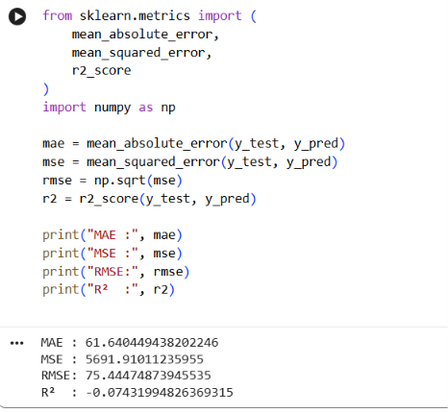
15. Complete Evaluation Code — Classification
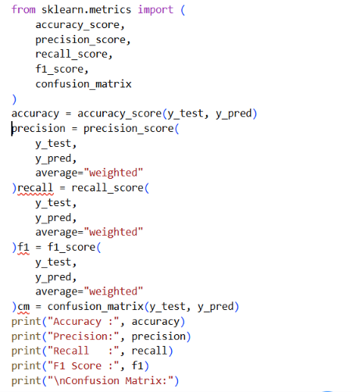

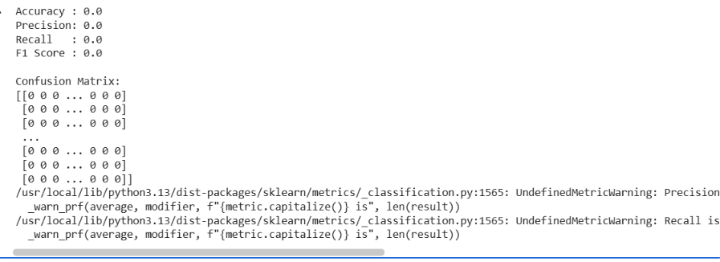

16. Why Model Evaluation is Important
Model evaluation is important because it helps us:
- Measure model performance
- Compare different models
- Identify prediction errors
- Select appropriate models for a specific application
- Understand classification behavior
- Determine whether a model generalizes adequately to unseen data

DAY 19 — Feature Engineering
Date:-29/09/2026
. What is Feature Engineering?
Description
Feature Engineering is the process of transforming raw data into useful features that can be effectively used by a Machine Learning model.
A feature is an input variable used by a model to make predictions.
Example
Suppose we have:
Age | Salary | City | Experience
25 | 30000 | Pune | 2
30 | 45000 | Mumbai | 5
28 | 40000 | Pune | 4
The ML model cannot directly understand text such as Pune and Mumbai. We need to transform the data.
After feature engineering:
Age | Salary | Experience | City_Mumbai
25 | 30000 | 2 | 0
30 | 45000 | 5 | 1
28 | 40000 | 4 | 0

2. Dataset for Day 19
You can use the Iris dataset because it is simple and suitable for demonstrating preprocessing and classification.
from sklearn.datasets import load_iris
import pandas as pd

iris = load_iris()

df = pd.DataFrame(
iris.data,
columns=iris.feature_names
)

df["target"] = iris.target

print(df.head())
Check the dataset
print(df.shape)
print(df.info())
print(df.describe())

3. Raw Data
Description
Raw data is the original data before cleaning or transformation.
Example:
Raw Data
↓
Missing Values
Duplicate Values
Different Data Types
Categorical Values
Outliers
↓
Needs preprocessing
Check missing values
print(df.isnull().sum())
Check duplicate records
print("Duplicates:", df.duplicated().sum())
Check data types
print(df.dtypes)

4. Data Cleaning
Description
Data cleaning means identifying and correcting problems in the dataset before using it for Machine Learning.
Common cleaning operations:
- Handle missing values
- Remove duplicates
- Correct data types
- Handle incorrect values
- Handle outliers when appropriate
Remove duplicates
df = df.drop_duplicates()
Handle missing numerical values
df["sepal length (cm)"] = df["sepal length (cm)"].fillna(
df["sepal length (cm)"].median()
)
Why?
Clean data helps create a reliable and reproducible ML workflow.

5. Feature Creation
Description
Feature Creation means creating a new feature from existing features.
Example
Suppose we have:
Height
Weight
We can create:
BMI = Weight / Height²
Python
df["BMI"] = df["Weight"] / (df["Height"] ** 2)
Another example
If a dataset contains:
Quantity
Price
we can create:
df["Total_Amount"] = df["Quantity"] * df["Price"]
Why Feature Creation?
New features can provide useful information that was not directly available in the original columns.

6. Feature Selection
Description
Feature Selection means selecting relevant features and removing features that are unnecessary or potentially harmful.
Example
Suppose we have:
Age
Salary
Experience
Customer_ID
Name
Customer_ID and Name may not be useful predictive features in many ML problems.
We can select:
X = df[
[
"Age",
"Salary",
"Experience"
]
]
Benefits
- Reduces unnecessary variables
- Can reduce model complexity
- Can improve computational efficiency
- Can reduce noise

7. Encoding
What is Encoding?
Machine-learning algorithms generally require numerical inputs. Encoding converts categorical variables into numerical representations.
Example
Gender

Male
Female
Male
After encoding:
1
0
1

7.1 Label Encoding
Label encoding assigns an integer to each category.
Example:
Male → 1
Female → 0
Python
from sklearn.preprocessing import LabelEncoder

encoder = LabelEncoder()

df["Gender"] = encoder.fit_transform(df["Gender"])
Important
Label encoding is appropriate in some situations, but assigning arbitrary integers to nominal categories can imply an artificial order. For many nominal categorical variables, one-hot encoding is preferable.

8. One-Hot Encoding
Description
One-hot encoding creates separate binary columns for categories.
Example:
City

Pune
Mumbai
Delhi
Becomes:
City_Delhi | City_Mumbai | City_Pune
0 | 0 | 1
0 | 1 | 0
1 | 0 | 0
Python
df = pd.get_dummies(
df,
columns=["City"],
drop_first=True
)
Why drop_first=True?
It removes one reference category and can help avoid redundant dummy variables in certain linear-model settings.

9. Scaling
Description
Scaling transforms numerical features so that their magnitudes are comparable.
For example:
Age = 25
Salary = 50000
Experience = 3
Salary has a much larger numerical magnitude than age.
Some algorithms are sensitive to these differences.

10. Standardization
Standardization transforms values approximately to:
Mean = 0
Standard Deviation = 1
Formula
z=x−μσz = \frac{x-\mu}{\sigma}
Where:
- x = original value
- μ = mean
- σ = standard deviation
Python
from sklearn.preprocessing import StandardScaler

scaler = StandardScaler()

X_scaled = scaler.fit_transform(X)

11. Min-Max Scaling
Description
Min-Max Scaling commonly transforms values to a specified range, usually 0 to 1.
Formula
X′=X−XminXmax−XminX' = \frac{X-X_{min}}{X_{max}-X_{min}}
Python
from sklearn.preprocessing import MinMaxScaler

scaler = MinMaxScaler()

X_scaled = scaler.fit_transform(X)
Difference
StandardScaler | MinMaxScaler
Centers around mean 0 | Usually scales to 0–1
Uses mean and standard deviation | Uses minimum and maximum
Commonly used in many ML workflows | Useful when a bounded range is desired

12. Train/Test Split
Description
Train/Test Split divides the dataset into two parts:
Training Data
Used to train the model.
Testing Data
Used to evaluate the model on unseen data.
Example
For 100 records:
100 Records
↓
80% → Training = 80
20% → Testing = 20
Python
from sklearn.model_selection import train_test_split

X_train, X_test, y_train, y_test = train_test_split(
X,
y,
test_size=0.20,
random_state=42
)
Why?
The model should be evaluated on data that was not used during training.

13. Data Leakage
Description
Data leakage occurs when information from outside the training data improperly influences the model during training.
A common example is fitting a scaler on the complete dataset before splitting it.
Incorrect
scaler.fit_transform(X)

X_train, X_test, y_train, y_test = train_test_split(...)
Better approach
Fit preprocessing only on the training data and apply it to the test data.
A Pipeline helps enforce this correctly.

14. Cross-Validation
Description
Cross-validation evaluates a model using multiple train/validation splits.
A common approach is K-Fold Cross-Validation.
Example — 5 Fold
Dataset
────────────────────────
Fold 1 → Validation
Fold 2 → Validation
Fold 3 → Validation
Fold 4 → Validation
Fold 5 → Validation
Each fold gets a turn as the validation set.
Python
from sklearn.model_selection import cross_val_score
from sklearn.linear_model import LogisticRegression

model = LogisticRegression(max_iter=1000)

scores = cross_val_score(
model,
X,
y,
cv=5
)

print("Scores:", scores)
print("Mean Score:", scores.mean())
Advantages
- Uses multiple train/validation splits
- Gives a more robust estimate than one split alone
- Helps compare models

15. Hyperparameter Tuning
Description
Hyperparameters are model settings selected before or during model training rather than learned directly from the training data.
Example for a Decision Tree:
max_depth
min_samples_split
min_samples_leaf
Hyperparameter tuning searches for suitable combinations.

16. GridSearchCV
Description
GridSearchCV tests combinations of specified hyperparameters using cross-validation.
Example
from sklearn.model_selection import GridSearchCV
from sklearn.tree import DecisionTreeClassifier

model = DecisionTreeClassifier(
random_state=42
)

parameters = {
"max_depth": [2, 3, 5, 10],
"min_samples_split": [2, 5, 10]
}

grid = GridSearchCV(
model,
parameters,
cv=5,
scoring="accuracy"
)

grid.fit(X_train, y_train)

print("Best Parameters:")
print(grid.best_params_)

print("Best CV Score:")
print(grid.best_score_)

17. RandomizedSearchCV
Description
RandomizedSearchCV samples a specified number of parameter combinations rather than exhaustively testing every combination.
This can be useful when the hyperparameter search space is large.
from sklearn.model_selection import RandomizedSearchCV

search = RandomizedSearchCV(
model,
parameters,
n_iter=5,
cv=5,
random_state=42
)

search.fit(X_train, y_train)

print(search.best_params_)

18. Pipeline
Description
A Pipeline combines multiple preprocessing and modeling steps into a single workflow.
Instead of manually performing:
Scaling
↓
Model
we can create:
Input Data
↓
Scaler
↓
Model
Python
from sklearn.pipeline import Pipeline
from sklearn.preprocessing import StandardScaler
from sklearn.linear_model import LogisticRegression

pipeline = Pipeline([
("scaler", StandardScaler()),
("model", LogisticRegression(max_iter=1000))
])

pipeline.fit(X_train, y_train)

y_pred = pipeline.predict(X_test)
Advantages
- Keeps preprocessing organized
- Reduces data leakage risk
- Makes training and prediction consistent
- Easier to reuse
- Works well with cross-validation and hyperparameter tuning
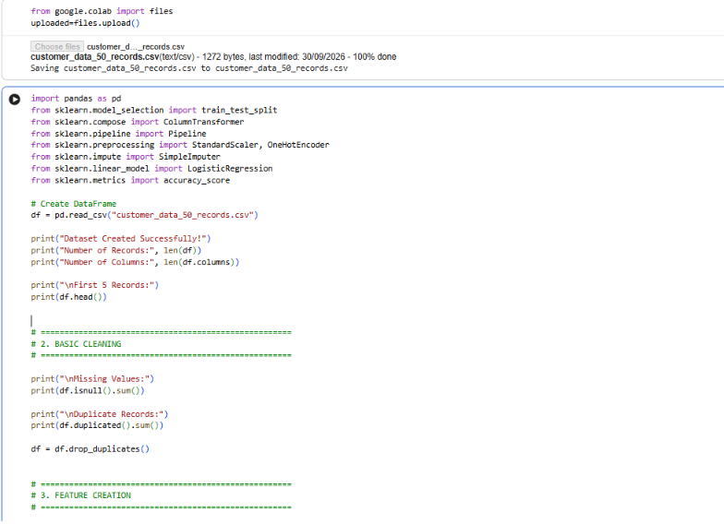
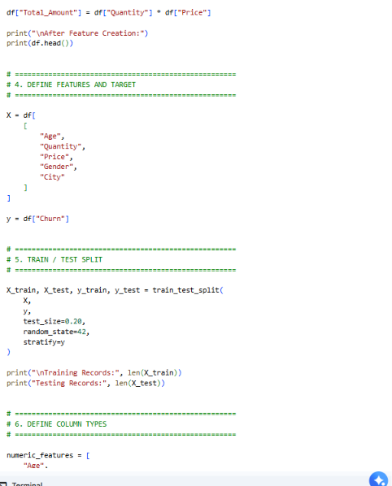
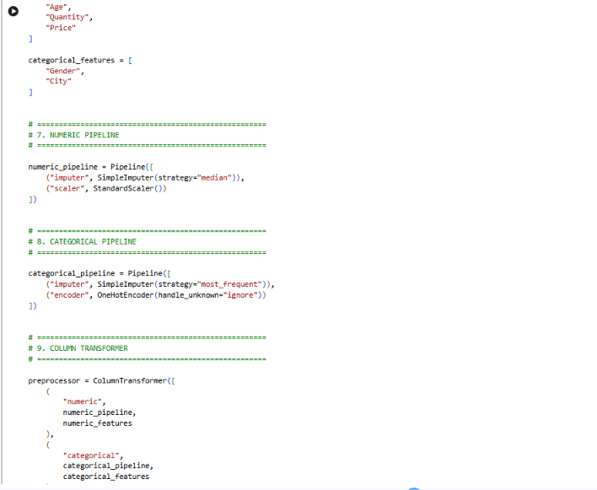
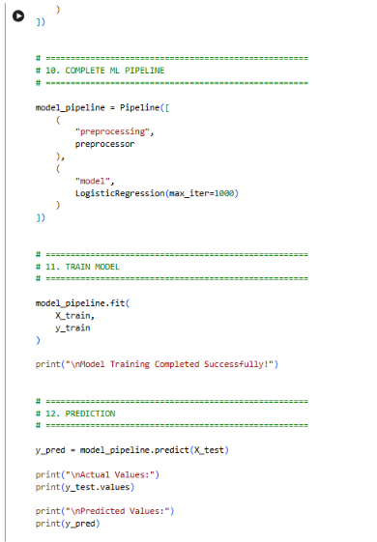
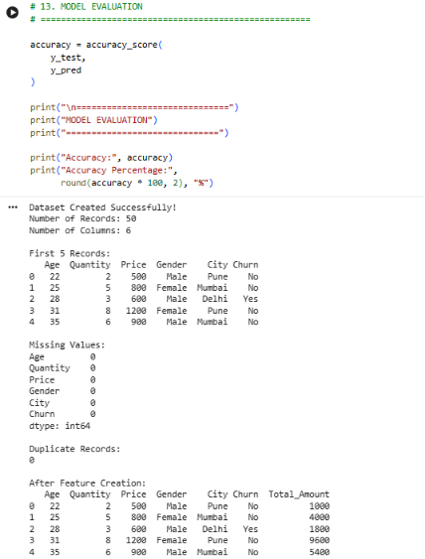
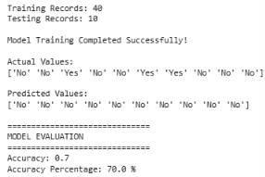
Final Pipeline
RAW DATA
↓
DATA CLEANING
↓
FEATURE ENGINEERING
↙ ↘
FEATURE SELECTION FEATURE CREATION
↓
ENCODING
↓
SCALING
↓
TRAIN / TEST SPLIT
↓
PIPELINE
↓
MODEL
↓
CROSS-VALIDATION
↓
HYPERPARAMETER TUNING
↓
FINAL EVALUATION
Conclusion
Feature Engineering is an important practical Machine Learning skill because raw data usually cannot be directly supplied to a model. A complete preprocessing workflow prepares the data through cleaning, feature creation, feature selection, encoding, scaling, and train/test splitting. Pipelines, cross-validation, and hyperparameter tuning then make the workflow more reliable, reproducible, and suitable for real-world ML projects.

